Code Cracking:
Decoding Cancer Causing Mutations
STEM Global Teacher Workshop
NWABR | nwabr.org
https://www.wghalliance.org/initiative/stem-global/resources/
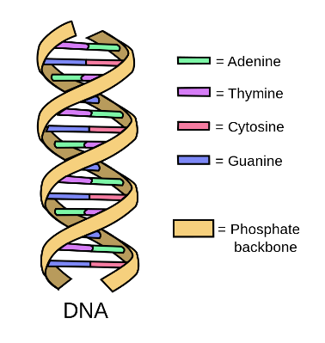
Time: 3 or more 50 minute class periods (assuming in-person instruction)
Subject & Grade Level(s): High School Biology, Grades 9-10
Brief Overview: This lesson is intended to be integrated into a High School Biology genetics unit and allows students to investigate and understand that cancer is a result of an accumulation of mutations in the genes that control cell proliferation. Cancer has a global impact, impacting lives around the world. However, cancer (both rates of incidences and cancer related deaths) disproportionately affects people in different countries of the globe. Students will learn about risk factors and prevention strategies to help them unpack some of the reasons for these disparities. In the culminating mini-project, students will conduct online research on the global disparities of cancer by investigating either a type of cancer across multiple countries/regions or the rates of different types of cancer in a single country/region. Optional extension activities are included.
This lesson plan is divided up into three parts which can be enacted over three class periods. Day One is focused on cancer as a molecular disease. Day Two is focused on mutations and the cell cycle. Day Three engages students in examining global disparities of cancer incidences and rates.
Teachers may choose to use this lesson as a launch event and puzzling scientific phenomenon for their genetics unit, using cancer as an authentic case for understanding different concepts in genetics. Alternatively, teachers may choose to leverage these activities as a culminating project for their genetics unit, where students will be challenged to apply their foundational understanding of genetics to a cancer-related phenomenon. Regardless of how teachers opt to position it, these activities will engage students in an exploration of the global burden of cancer. This lesson plan has been revised with suggestions for remote instruction.
(Image credit: Forluvoft, 2008, Wikimedia Commons).

STUDENT UNDERSTANDINGS
Anchoring Phenomenon: Cancer has a global impact, impacting lives around the world. However, cancer (both rates of incidences and cancer related deaths) disproportionately affects people in different countries of the globe.
DNA is a molecule that contains all the information that allows an organism to develop, live, and reproduce. Genes are the areas of DNA that code for proteins, which are the workhorses of the cell. Cancer is a result of the accumulation of mutations in the genes that control cell proliferation. While a small number of these mutations are inherited, the majority are acquired either spontaneously or caused by external agents. Because cancer is a result of uncontrolled cell division its development is linked to mutations in cells that control cell proliferation.
Driving Question: How can an understanding of genetics help us investigate why cancer (both rates of incidences and cancer related deaths) disproportionately affects people in different countries of the globe?
NEXT GENERATION SCIENCE STANDARDS
This lesson builds toward the following high school level Performance Expectation (PE) from the Next Generation Science Standards.
HS-LS1-1: From Molecules to Organisms—Structures and Processes. Construct an explanation based on evidence for how the structure of DNA determines the structure of proteins, which carry out the essential functions of life through systems of specialized cells.
HS-LS1-4: From Molecules to Organisms—Structures and Processes. Use a model to illustrate the role of cellular division (mitosis) and differentiation in producing and maintaining complex organisms.
HS-LS3-2: Heredity—Inheritance and Variation of Traits. Make and defend a claim based on evidence that inheritable genetic variations may result from (1) new genetic combinations from meiosis, (2) viable errors occurring during replication, and/or (3) mutations caused by environmental factors.

Download this lesson plan and associated student handouts at the STEM Global Resources page: https://www.wghalliance.org/initiative/stem-global/resources/

Credit: The Code Cracking lesson plan and associated materials were developed by Wendi Russac of the Northwest Association for Biomedical Research, a non-profit organization located in Seattle, WA and adapted for a STEM Global Educator Workshop in November 2019. Lesson plan development, editing, and adaptations for remote instruction provided by Kristen Bergsman of Laughing Crow Curriculum LLC.

