Data Detective:
Investigating the Human Health Effects of Air Pollution in Washington State
Middle School Version
STEM Global Teacher Workshop
IHME | healthdata.org
https://www.wghalliance.org/initiative/stem-global/resources/

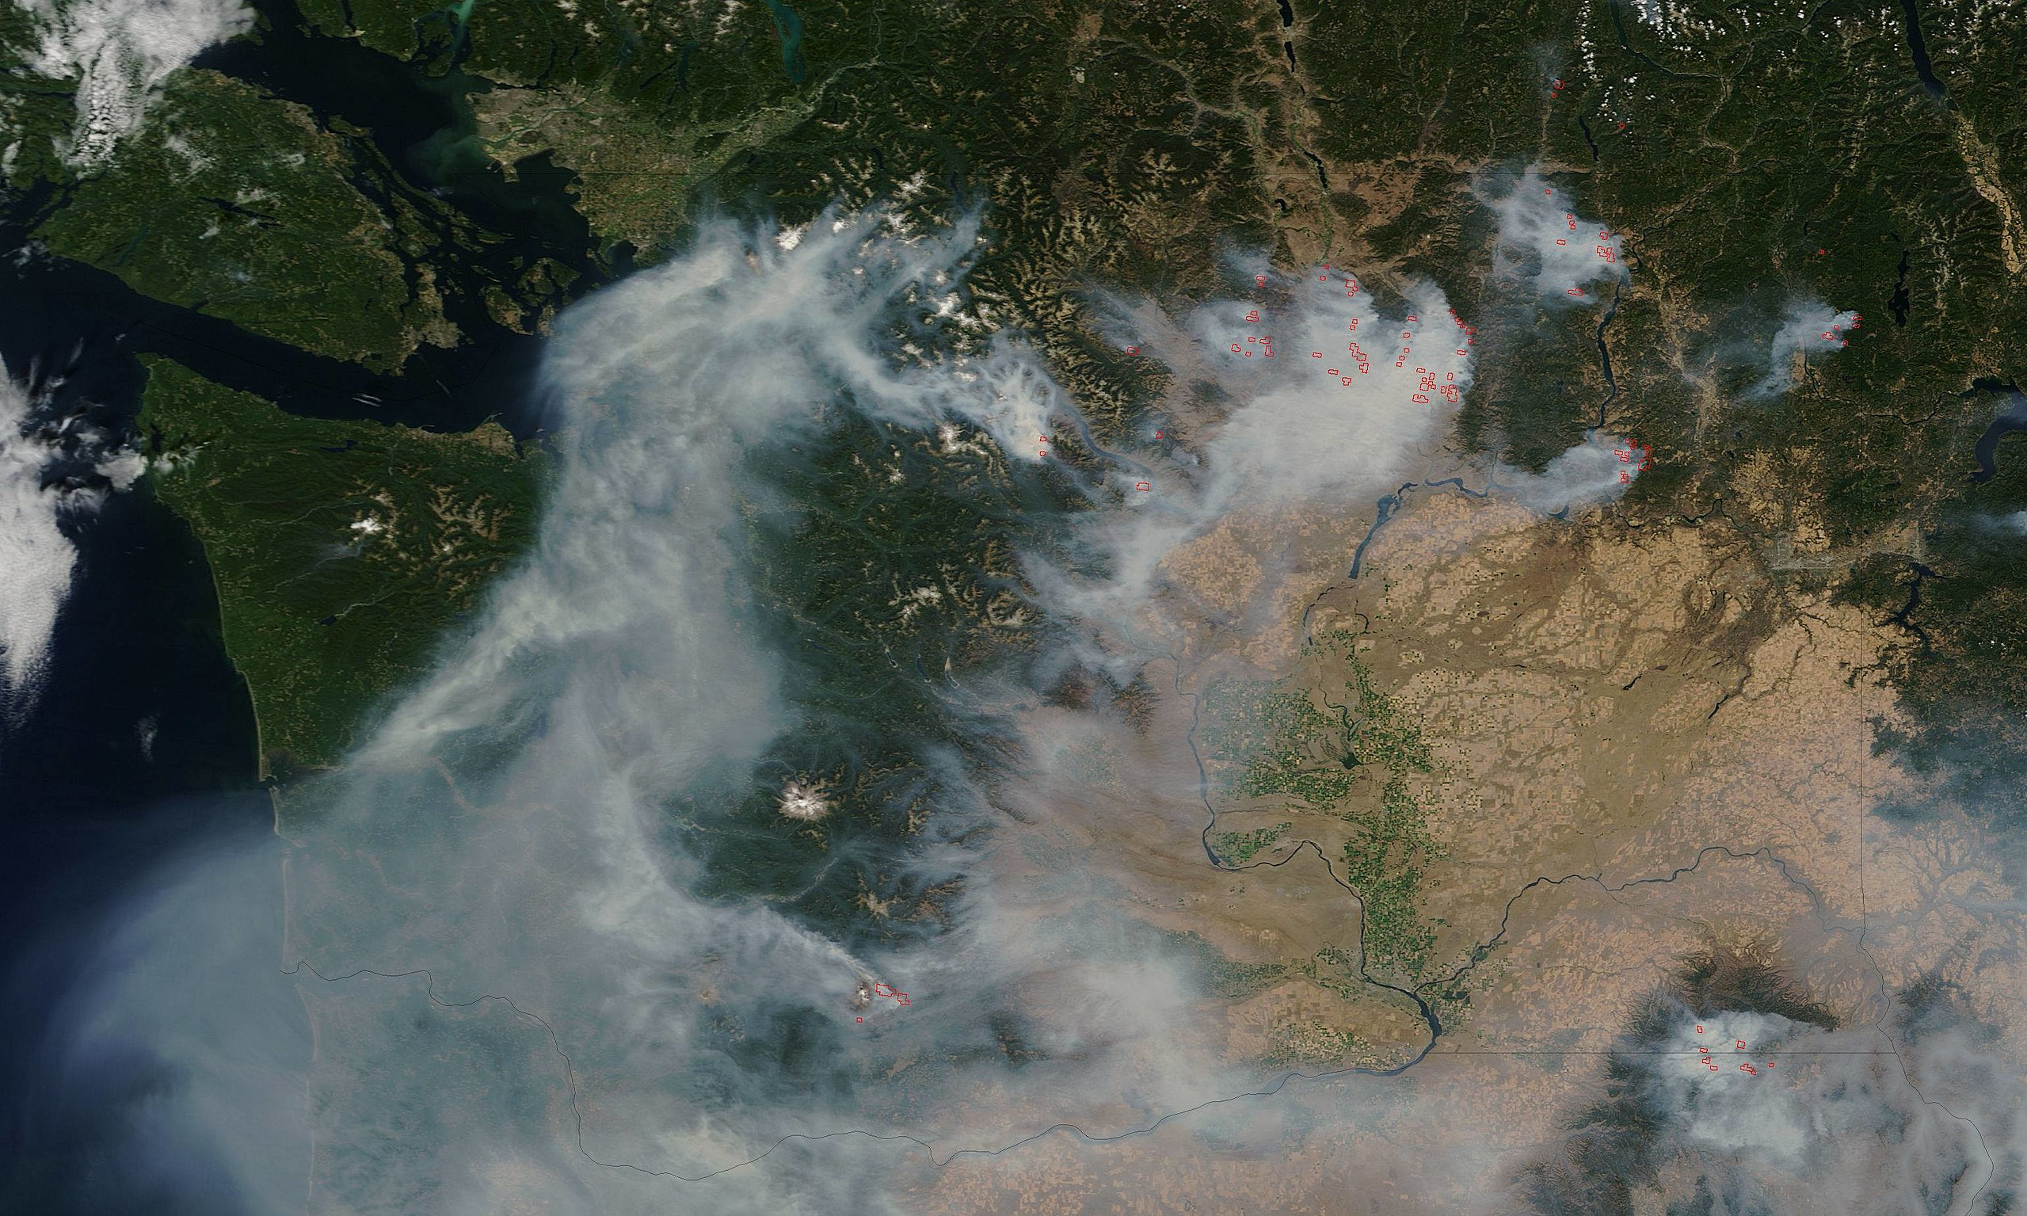

Time: 3 50 minute class periods
Subject & Grade Level(s): HS Earth and Space Sciences (Grades 6-8). This lesson incorporates mathematics and computational thinking concepts and practices.
Brief Overview: In this data science lesson, students practice analyzing and interpreting data in order to answer an investigative question about air pollution in Washington. Student groups first collaborate to graph air pollution data from a city in Washington State. They then compile data as a class in order to observe trends and patterns across cities to make a claim about whether the time of year affects the amount of air pollution in Washington. Through this lesson, students will develop an understanding of foundational data science principles and recognize techniques for manipulating and analyzing data. Students will also gain skills in interpreting trends and patterns in data and writing evidence-based claims. In addition, students will gain an understanding of how air pollution affects human health and the global epidemiology of outcomes attributed to air pollution.
This lesson was originally developed by the Institute for Health Metrics and Evaluation (IHME), an institute affiliated with the University of Washington focused on health metrics sciences (this middle school adaptation of the lesson by Laughing Crow Curriculum). As such, this lesson attempts to introduce students to fundamental data sciences practices that are the work of scientists across fields, including global health. (Image credit: Wikipedia). Updated January 2021 with suggested adaptations for remote learning.

STUDENT UNDERSTANDINGS
Anchoring Phenomenon: Exposure to outdoor (ambient) air pollution is a major risk factor for disease for people around the world. There is a wide array of health effects which are believed to be associated with air pollution exposure. Among them are respiratory diseases (including asthma and changes in lung function), cardiovascular diseases, adverse pregnancy outcomes (such as preterm birth), and even death. While air pollution is a global phenomenon, it has very local impacts that can profoundly affect communities in unique and profound ways. In Washington State for instance, increasing temperatures, rapid urbanization, increased manufacturing, and natural disasters can affect the region’s air quality which, in turn, can contribute to poorer health outcomes for residents. In order to alleviate/mitigate the consequences of air pollution in Washington State, we must assess and understand levels and trends of exposure to air pollution to better identify solutions and interventions.
Driving Questions
- How can data be used to understand changing levels of air pollution exposure in the State of Washington?
- How can we present air pollution data in a way that reveals patterns or relationships?
- What are the health effects from outdoor air pollution exposure to Washington residents?
- How can data be used to make predictions and recommendations about air pollution and human health?

NEXT GENERATION SCIENCE STANDARDS
This lesson builds toward the following middle school level Performance Expectation (PE) from the Next Generation Science Standards.
MS-ESS3-3: Apply scientific principles to design a method for monitoring and minimizing a human impact on the environment.

Download this lesson plan and associated student handouts at the STEM Global Resources page: https://www.wghalliance.org/initiative/stem-global/resources/

Credit: This activity was originally developed as a high school-level lesson by the Institute for Health Metrics and Evaluation (IHME), a global health organization located in Seattle, WA and adapted for a STEM Global Teacher Workshop in April 2019. Original authors include: Austin Carter, Doctoral Candidate and Researcher, IHME; Joseph Frostad, Doctoral Candidate and Researcher, IHME; Sean Lassiter, Senior Education Program Manager. This middle school-level adaptation was authored by Janneke Petersen for Laughing Crow Curriculum. Lesson plan development, editing, and adaptations for remote instruction provided by Dr. Kristen Bergsman of Laughing Crow Curriculum.

